Personal Finance Manager

1. Introduction
The Personal Finance Manager is a Python-based command-line application that helps users manage their daily income and expenses.
It provides features such as adding expenses, adding income, viewing reports, generating summaries, and backing up data.
This user manual explains how to use every feature in the app.

2. Starting the Application

How to Run
- Open Command Prompt / Terminal.
- Navigate to your project folder:
cd personal-finance-manager
- Run the application:
python main.py
You will see the main menu displayed.

3. Main Menu Options
When the program starts, the following menu appears:
MAIN MENU
1. Add Expense
2. View All Expenses
3. Add Income
4. View All Income
5. View Category-wise Expense Summary
6. Monthly Income Report
7. Income vs Expense Overview
8. Backup Data
9. Exit

4. Feature Guide (Step-by-Step)

4.1 Add New Expense
Use this option to record any spending.
You will be asked to enter:
- Date (YYYY-MM-DD)
- Category (Food, Transport, Shopping, etc.
- Amount
- Note (optional)
Example Input:
Date: 2025-11-10
Category: shopping
Amount: 1000
Note: Festival
✔ Expense added successfully!
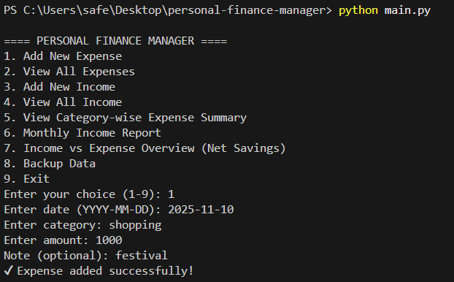

4.2 View All Expenses
Displays all saved expenses in a table format:
Example:
0 2025-01-03 Food 150 Breakfast at cafe
1 2025-01-04 Transport 40 Bus ticket
2 2025-01-05 Groceries 760 Weekly vegetables
3 2025-01-06 Shopping 1200 Clothing items

👉 Insert screenshot: 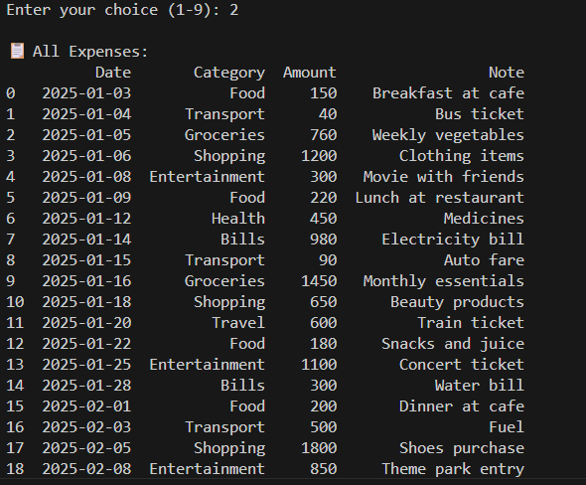

4.3 Add New Income
Use this option to record income such as salary, freelance payments, etc.
You will be asked to enter:
- Date (YYYY-MM-DD)
- Source
- Amount
- Note (optional)
Example:
Date: 2025-12-08
Source: Freelance Work
Amount: 5000
Note: Website project
✔ Income added successfully!
👉 Insert screenshot:
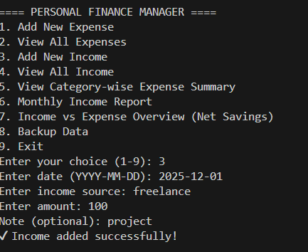

4.4 View All Income
Displays all income entries saved in the system.
Example:
0 2025-01-01 Salary 35000 Monthly salary credited
1 2025-01-05 Freelance 5000 Website design project
2 2025-01-12 Gifts 1500 Birthday gift from friend
3 2025-01-18 Online Selling 2200 Sold old books
👉 Insert screenshot: view_income.png
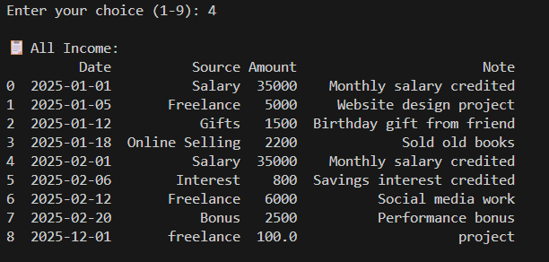

4.5 Category-wise Expense Summary
This feature shows the total amount spent in each category.
Example:
Bills 1280.0
Entertainment 2250.0
Food 750.0
Groceries 2210.0
Health 750.0

A bar chart will also be displayed (if matplotlib is installed).
👉 Insert screenshot: category_summary.png
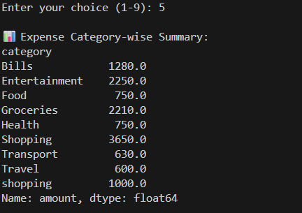

4.6 Monthly Income Report
Shows all income and expense totals grouped by month.
Example:
December 2025:
Bonus 2500.0
Freelance 11000.0
Gifts 1500.0
Interest 800.0
👉 Insert screenshot: monthly_report.png
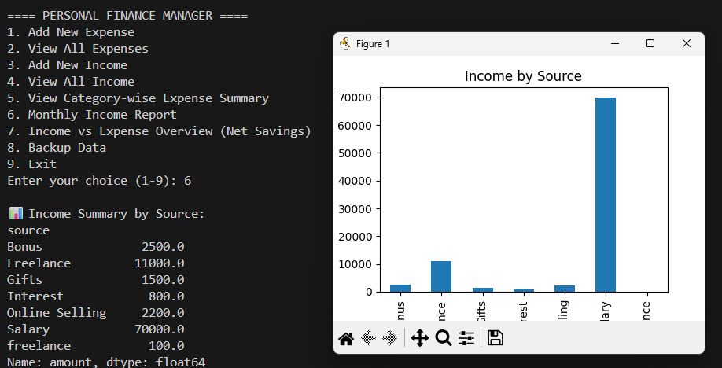

4.7 Income vs Expense Overview (Net Savings)
Shows your overall financial health:
- Total Income
- Total Expenses
- Net Savings
- Bar graph comparison (optional)
👉 Insert screenshot: income_vs_expense.png
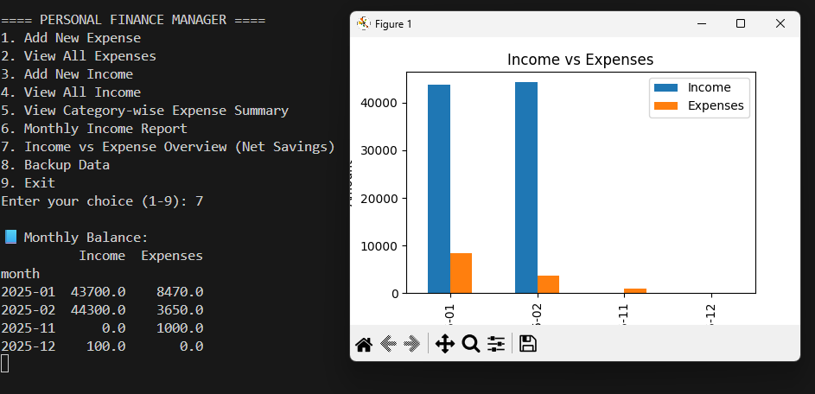

4.8 Backup Data
Creates a backup copy of your CSV files inside the backup/ folder.
Backup files:
- expenses_backup.csv
- income_backup.csv
You will see:
Backup created successfully!

4.9 Exit Program
Select this option to safely exit the application.
Thank you for using Personal Finance Manager!

5. File Storage Details
- data/expenses.csv — stores all expense entries
- data/income.csv — stores all income entries
- backup/ — stores backup copies
- Files are automatically updated after every entry

6. Tips for Best Use
✔ Enter dates in YYYY-MM-DD format
✔ Backup data regularly
✔ Use clear notes (e.g., "Lunch", "Petrol", "Freelance project")
✔ View reports weekly to track spending habits

7. Troubleshooting
Issue | Cause | Solution
App not starting | Missing libraries | Run pip install -r requirements.txt
Wrong date format | Entered 12/03/25 | Use YYYY-MM-DD
No graph appearing | Missing matplotlib | Install using pip
CSV file not showing data | File deleted/empty | Add new expense/income

8. Conclusion
Your Personal Finance Manager is ready to help you take control of your money.
It is simple, fast, and effective for daily tracking and financial analysis.

